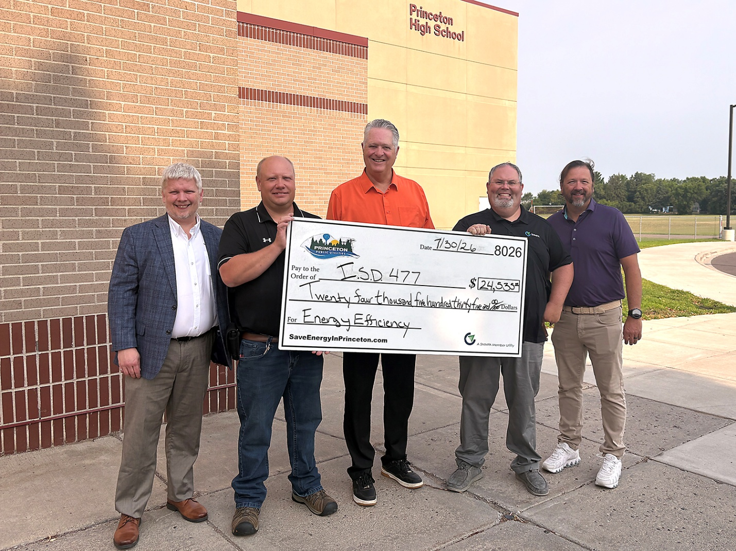

ISD 477 benefits big from Princeton Public Utilities rebates
ISD 477 recently received nearly $25,000 from Princeton Public Utilities for energy efficiency building improvements made during the past year. By partnering with the utility to take advantage of energy efficiency rebate programs, Princeton Public Schools upgraded air conditioning, lighting, motors, and VFDs throughout its four school buildings. Those improvements reduced the school district’s overall electric consumption and ultimately resulted in lower electric bills, which is win-win for everyone!
Princeton Public Utilities offers rebate programs to help its residential and business customers use energy wisely and lower their electric bills. In each of the last two years, the utility has paid more than $100,000 in rebates to help customers purchase energy-saving products.
Pictured (left to right) are Princeton Public Utilities General Manager Keith Butcher, ISD 477 Building & Grounds Director Jason Oldenkamp, ISD 477 Superintendent Pat Devine, SMMPA Energy Services Representative Brian Hammarsten and Nick Nowak of Steinbrecher Painting.

